**1 – Corporate Email**

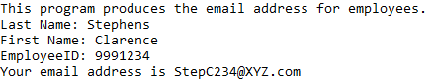

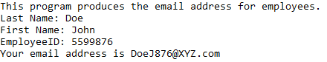

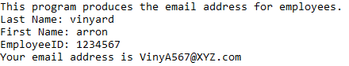

**2 – Date Formatting**

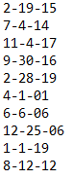

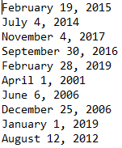

**3 – Dictionary Analysis**

